

CERTIFICATE

This is to certify that, Ms.Nikita Mahajan,Ms.Rajeshwari Mishra,Mr.Vikas Kushwaha are bonafide students of Thakur College of Engineering and Technology, Mumbai. They have satisfactorily completed the requirements of the PROJECT-I as prescribed by University of Mumbai while working on “Photo-realistic face images generation from textual description using GAN”.

Mrs. Shiwani Gupta  (Guide) | Dr. Harshali Patil  ( HOD COMP) | Dr. B. K. Mishra  (Principal)
Internal Examiner: External Examiner:

Signature with Date: …………….. Signature with Date: …………..

Name: …………………………….. Name: …………………………..

Thakur College of Engineering and Technology
Kandivali(E), Mumbai-400101.

PLACE: Mumbai
DATE:

Acknowledgement

We sincerely thank our guide Mrs. Shiwani Gupta for her guidance and constant support. We also thank the project coordinators for arranging the necessary facilities to carry out the project work.

We thank the HOD, Dr. Harshali Patil, Director, Dr. R.R Sedamkar, the Principal, Dr. B. K. Mishra and the college management for their support.

(Signature)
(Nikia Mahajan(56))
)

(Signature)
(Rajeshwari Mishra(62))

(Signature)
(Vikas Kushwaha(55))

ABSTRACT

Deep Neural networks are currently capable of providing human level solutions to a variety of problems such as image recognition, speech recognition, machine translation, natural language processing, and many more. . Deep convolutional generative adversarial networks (DCGANs) have proven capable at generating diverse, photorealistic images of human faces, but it is difficult and often time-consuming to choose what kind of image these generative adversarial networks (GANs) produce. Tasks like mapping textual data to visual data (i.e. lower dimension to higher dimension) is a feat which is still not easily achievable even by experts. The challenge here is extracting every possible information from lower dimension data to generate comparatively higher dimension data. This work collaborates GANs and Natural Language Processing (NLP) to come up with a model which will effectively translate human facial features from characters to pixels. In other words the model will generate realistic human faces given the description of the faces. We create a simple, intuitive web application through which users may write a description of a human face in plain text and generate photos that appear to match the given description.

INDEX

Chapter No. Design of a system to generate photo realistic Pg. No.
face images from textual description using GAN

• List of figures I

• List of Tables II
Chapter 1 Introduction

1.1 Introduction
1.2 Motivation
1.3 Problem Definition
1.4 Objectives of the Project
1.5 Scope of the Project
1.6 Applications of the Project
1.7 Expected Outcome of the Project
1.8 Organization of the Project Report

Chapter 2 Literature Review and Proposed Work

2.1 Literature Survey
2.2 Proposed Work

Chapter 3 Requirement Gathering, Analysis and Planning

3.1 Requirement Specification
3.2 Feasibility Study
3.3 Methodology
3.4 Technology
3.5 Gantt Chart and Process Model
3.6 System Analysis (functional model, structural model and behavioral model)

Chapter 4 Design Phase

4.1 Block Diagram/ Software architecture
4.2 Data Flow Diagram/Flowchart/Algorithm
4.3 Unified Modeling Language
4.4 User Interface Design (Snapshots)

Chapter 5 Conclusion
References

Propose Conference Paper

Appendix A
• Abbreviation and symbols
Appendix B
• Definitions

Chapter 1

Introduction

1.1 Introduction
Generation of photo realistic face images from textual description is a challenging problem which will serve the government and industry. Our Software system will help in police investigation and for criminal cases to generate face images of the criminal in real time. This could potentially be more accurate than the sketch. Our project aims to use GAN (Generative Adversarial Networks) to design the system model.

1.2 Motivation
As the crime cases are wide in number and to sketch the face of victim, police investigation department has to request the eyewitness to help the artist to provide the information to design a sketch which requires cost and will be time consuming but our system will give the nearest face image without any effort by just providing the face description in text format. So the model will effectively identify suspects in a police investigation.

1.3 Problem Definition
Synthesizing high-quality images from text descriptions is a challenging problem in computer vision and has many practical applications. Samples generated by existing text-to-image approaches can roughly reflect the meaning of the given descriptions, but they fail to contain necessary details and vivid object parts. We are motivated by the potential of automated face generation to impact and assist critical tasks such as criminal face reconstruction.

1.4 Objectives of Project
1.To generate images that would produce stable appearance patterns and the diverse expressions of humans.
2.To focus on text irrelevant contents in the original image and global coherent structure.
3. To improve the diversity of synthesized images and increase the visual quality and resolution.

1.5 Scope of the project
1)Text-to-face generation has huge potential in the public safety domain.
2)It also has huge application potentials in art creation, computer-aided design, image searching and so on.
3)This technology can be used in many good things like criminal face reconstruction.
4)It has the ability to translate photographs across domains, such as day to night, summer to winter, and many more.

1.6 Application of project
1) In Criminal cases for the police investigation department
2) Useful For Engineers, scientists, designers.
3) It is designed for government and industrial use.

1.7 Projects Impact Analysis
The impact of the project system model can be categorized into the following:
Financial Impact analysis: Face generation from text will significantly reduce individual and government spending as the model will be budget friendly.
Time Impact analysis: It is less time consuming as it provides the output with no delay.
Social Impact analysis: Model can be used in social media.
Environmental Impact analysis: There is no direct environmental impact.
Industrial and Government Impact: It is designed to serve the police and criminal cases.

1.8 Expected Outcome
1) System is stable and does the prediction properly.
2) Results are accurate with the proper percentage of efficiency.
3) Increase in visual quality along with high resolution.
4) Gaps are reduced between the generated and original image.

1.9 Organization of the Project report
Chapter 1:It consists of the introduction of the project. Along with the problem definition is explained .Also the motivation for the project ,scope , objectives ,outcomes, impacts of the project.
Chapter 2:This chapter mainly deals with the literature review and the proposed work of the project.
Chapter 3: This chapter deals with the initial stages of the projects like requirements gathering etc.
Chapter 4:This chapter deals with the design part of the project. Its consists of the diagrams .
Chapter 5:This consists of the conclusion of the project.

Chapter 2

Proposed Work and Literature Review

2.1 Literature Survey

Sr.no | Title of the paper | Journal and year of publication | Summary of the paper | Gap identified
1. | Text2FaceGAN: Face Generation from Fine Grained Textual Descriptions | 2019 IEEE Fifth International Conference on Multimedia Big Data (BigMM) | In this work they presented captions for the CelebA dataset to facilitate face synthesis from text. Then they used Generative Adversarial Network to learn the conditional multimodality in synthesis of face from captions. | Improve the selection of the wrong image for the GAN-CLS algorithm. Currently, they randomly select images from the dataset as the wrong image .Explore better language models such as BERT, analyze and compare performance of other GAN architectures with their model for face generation from captions
2. | AttnGAN: Fine-Grained Text to Image Generation with Attentional Generative Adversarial Networks | 2018 IEEE/CVF Conference on Computer Vision and Pattern Recognition. | Attentional Generative Adversarial Network is proposed for fine-grained text-to-image synthesis which gives effective results for complex scenes. | To work on global coherent structure to eliminate the failure which could not be resolved by the current method.
3. | StackGAN: Text to Photo-realistic Image Synthesis  with Stacked Generative Adversarial Networks | 2017 IEEE International Conference on Computer Vision. | It proposed the Stacked Generative Adversarial Networks (StackGAN) to generate 256×256 photo realistic images conditioned on text description & the outcome generated has higher resolution as compared to text-to-image generative models. | To improve the diversity of synthesized images and to stabilize the training of Conditional GAN introduced Conditioning Augmentation Technique.
4. | A style-based generator architecture for generative adversarial networks | 2019 IEEE Conference on Computer Vision and Pattern Recognition. | They proposed an alternative generator architecture for generative adversarial networks, borrowing from style transfer literature. The new architecture leads to an automatically learned, unsupervised separation of high-level attributes and stochastic variation in the generated images and it enables intuitive, scale-specific control of the synthesis. | We should also focus on text irrelevant contents in the original image.
5. | Photographic Text-to-Image Synthesis with a Hierarchically-nested Adversarial Network | 2018 IEEE/CVF Conference on Computer Vision and Pattern Recognition. | This paper presents a novel method to deal with the challenging task of generating photographic images conditioned on semantic image descriptions. The method introduces accompanying hierarchical-nested adversarial objectives inside the network hierarchies, which regularize mid-level representations and assist generator training to capture the complex image statistics. | Focus on increasing the visual quality and resolution of generated images.

2.2 Proposed Work

Generative Adversarial Network (GAN) for Text-to-Image. Goodfellow et al. first introduced the adversarial process to learn generative models. The Generative Adversarial Network (GAN) is generally composed of a generator and a discriminator, where the discriminator attempts to distinguish the generated images from real distribution and the generator learns to fool the discriminator. A set of constraints are proposed in previous works to improve the training process of GANs, e.g., interpretable representations are learned by using additional latent code. GAN-based algorithms show excellent performance in image generation. Reed et al. first showed that the conditional GAN was capable of synthesizing plausible images from text descriptions. Zhang et al. stacked several GANs for text-to-image synthesis and used different GANs to generate images of different sizes. Their following works also demonstrated the effectiveness of stacked structures for image generation. Xu et al. developed an attention mechanism that enables GANs to generate fine-grained images via word-level conditioning input.

Chapter 3

3.1 Requirement Gathering, Analysis and Planning

Functional
• Photo-Realistic Face Generation
• Intuitive User Interface
These are the main functional requirements because without them, we wouldn’t be meeting the client’s specifications. The GAN needs to be able to generate photo-realistic faces based on user provided descriptions, as this is the main goal of the project. The website will have an intuitive interface that will make it easy for users to interact with our model and generate images at their discretion.
Nonfunctional
• Recognizably Human Generated Faces
• Faces Appear Derived from Text Description
We intend to have our GAN generate faces that look like human faces. The more similar our generated faces are to actual human faces, the more we will have succeeded in this requirement. We want to ensure that the faces our GAN generates are reasonably similar to the description provided by the user.
Constraints
• Time
• Computing Resources
Time will be a constraint in terms of development of the GAN architecture and training the GAN.

3.2 Feasibility Study (FAD)

· Technical: Tools and Technologies involved are jupyter notebook, python and list of libraries like pandas, nltk, matplotlib, scikit-learn, tensorflow etc. Which is needed for our project which involves data preprocessing, applying feature engineering and then generating the photorealistic image based on text; development tools for deployment of the project. So, our project is technically feasible.

· Legal: The dataset used will be taken from open source platform i.e. Kaggle.com.

· Economic: No additional hardware is required.

3.3 Methodology

Our problem is not simply one of generating images of faces, but of generating images based on a text input. This calls for using CGANs. Goodfellow et. al. mention future work involving conditional GANs where the conditioning vector is part of the input to both the generator and the discriminator. With advances in natural language understanding (NLU), neural networks have been able to perform better on language tasks than ever before. This means that the features learned by a NLU model may be much more useful than an encoded word vector. Reed et. al. do this in their 2016 paper on text to image synthesis using GANs. They use a pre-trained NLU model to get a feature vector from the text data and then input it to the beginning of the generator and after the image has been mostly processed in the discriminator of a typical DCGAN. They show this is effective on popular bird and flower datasets. Nasir et. al. in their 2019 paper show that this same methodology can be applied to human faces. Because the face dataset does not contain raw text, the authors write an algorithm to deterministically turn a set of binary descriptors like (female, has brown hair, chubby face) into a sentence or series of sentences that seem like natural language. Because there simply does not exist a large dataset of images of human faces with corresponding text descriptions, this is the next-best method to try to test CGANs in generating images of human faces. We do something similar in order to properly train our model.

3.4 Technology

• As a team, we have some experience with Python. Python is very flexible because of the frameworks that make the development of websites and applications quick and easy. There are also many deep learning and data-processing frameworks available in Python, making training of the GAN easier.
• Keras is a high-level Python API for deep learning model development, training, and deployment, and we will be using the Tensorflow back-end for it. Keras having a Python API means it easily interacts with our web-based components as well. We also have more experience with Keras compared to other frameworks.
• HTML and CSS will help us develop the front-end of our website and make the user interface more aesthetically pleasing and intuitive.
• JavaScript is used as a way of dynamically modifying our HTML code. This is necessary because pictures are not displayed on the website until the user generates faces, so we need to use JavaScript to change the web page once those pictures have been created in order to display them.
• Google Cloud Platform gave us access to cloud computing resources which aided us in working with and training the various models we attempted to use for our project.
• GitHub was used to aid with version control for the project.
• For deploying the website, we used AWS because it provided enough storage and RAM for the model to be run.

3.5 Gantt Chart and Process Model and Client Communication



3.6 System Analysis (functional model, structural model and behavioral model)

Chapter 4

Design phase

4.1 Architecture Diagram

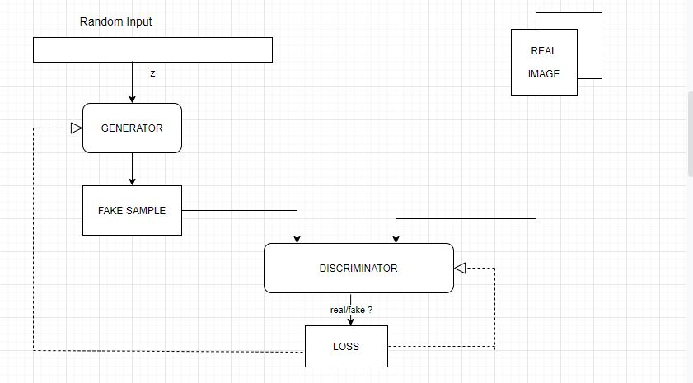

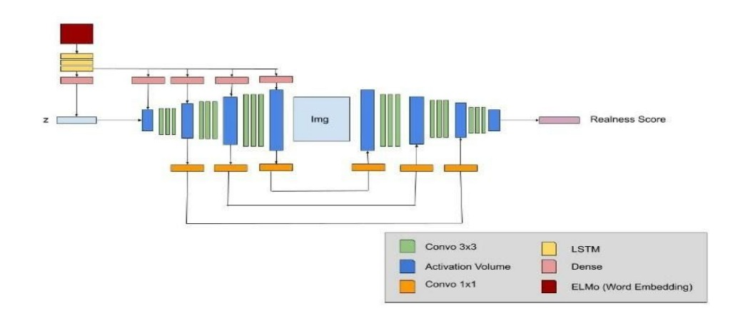

4.2 Data flow diagram

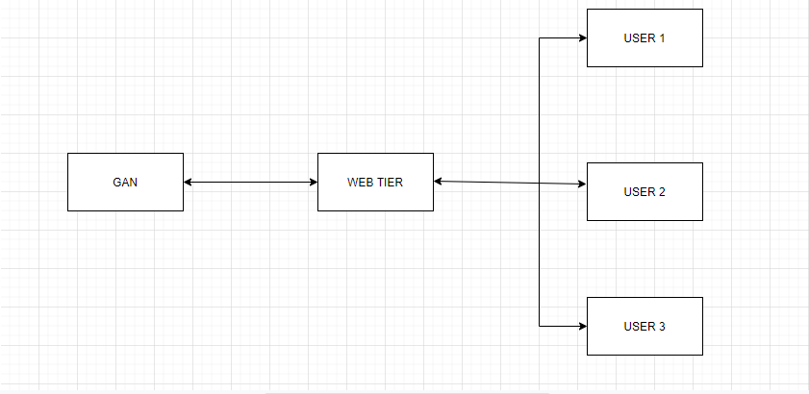

4.3 Unified Modeling Language

4.3.1 Activity Diagram
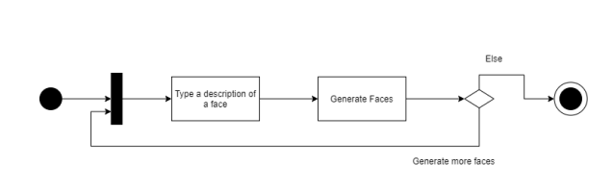

4.3.2 Use Case Diagram

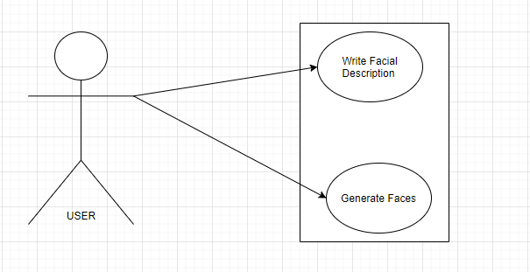

4.4 User Interface Design (Snapshots)

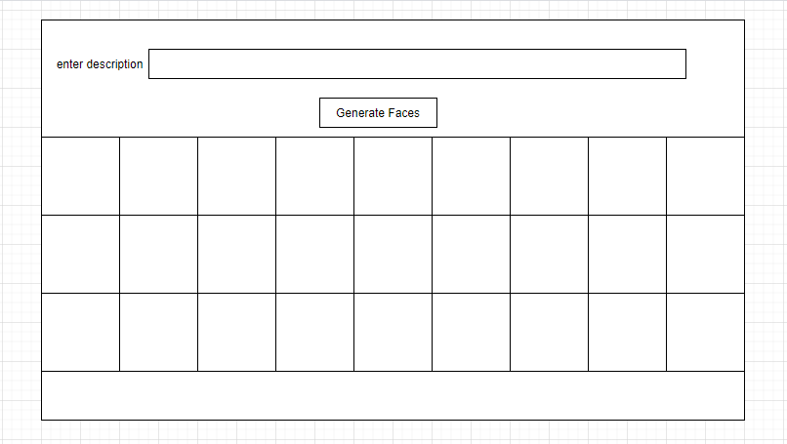

Website layout

Chapter 5

Conclusions

We can assert that Text to Face Generation is a viable project with some very interesting applications. For instance, Text to face can help in identifying certain perpetrators / victims for the law agency from their description. It can also be used in applications where people can write their face description and can get their face generated.

The application can be used by both the government as well as industry.

References

[1] Osaid Rehman Nasir, Shailesh Kumar Jha, Manraj Singh Grover, Yi Yu†, Ajit Kumar and Rajiv Ratn Shah, “Text2FaceGAN: Face Generation from Fine Grained Textual Descriptions” 2019 IEEE Fifth International Conference on Multimedia Big Data (BigMM).
[2] Han Zhang, Tao Xu, Hongsheng Li, Shaoting Zhang, Xiaogang Wang, Xiaolei Huang, Dimitris Metaxas in “StackGAN: Text to Photo-realistic Image Synthesis with Stacked Generative Adversarial Networks” 2017 IEEE International Conference on Computer Vision, pp. 5907–5915.
[3] Tao Xu, Pengchuan Zhang, Qiuyuan Huang, Han Zhang, Zhe Gan, Xiaolei Huang, Xiaodong He, “AttnGAN: Fine-Grained Text to Image Generation with Attentional Generative Adversarial Networks” 2018 IEEE/CVF Conference on Computer Vision and Pattern Recognition.
[4] Zizhao Zhang, Yuanpu Xie, and Lin Yang, “Photographic text-to-image synthesis with a hierarchically-nested adversarial network,” in Proceedings of the IEEE Conference on Computer Vision and Pattern Recognition, 2018, pp. 6199– 6208.
[5] Tero Karras, Samuli Laine, and Timo Aila, “A style-based generator architecture for generative adversarial networks,” in Proceedings of the IEEE Conference on Computer Vision and Pattern Recognition, 2019, pp. 4401–4410.
[6] Guojun Yin, Bin Liu , Lu Sheng, Nenghai Yu , Xiaogang Wang , Jing Shao, “Semantics Disentangling for Text-to-Image Generation” arXiv:1904.01480v1 [cs.CV] 2 Apr 2019.
[7] Micah Hodosh, Peter Young, and Julia Hockenmaier, “Framing image description as a ranking task: Data, models and evaluation metrics,” Journal of Artificial Intelligence Research, vol. 47, pp. 853–899, 2013.
[8] Zizhao Zhang, Yuanpu Xie, and Lin Yang, “Photographic text-to-image synthesis with a hierarchically-nested adversarial network,” in Proceedings of the IEEE Conference on Computer Vision and Pattern Recognition, 2018, pp. 6199– 6208.

